Project Design Phase-II
Data Flow Diagram & User Stories

Date | 12 January 2026
Team ID | SWTID-2026-7310
Project Name | Auto Ticket Classification using Flow Designer
Maximum Marks | 4 Marks

Data Flow Diagrams:
A Data Flow Diagram (DFD) is a traditional visual representation of the information flows within a system. A neat and clear DFD can depict the right amount of the system requirement graphically. It shows how data enters and leaves the system, what changes the information, and where data is stored.

Level-1 DFD - Auto Ticket Classification using Flow Designer
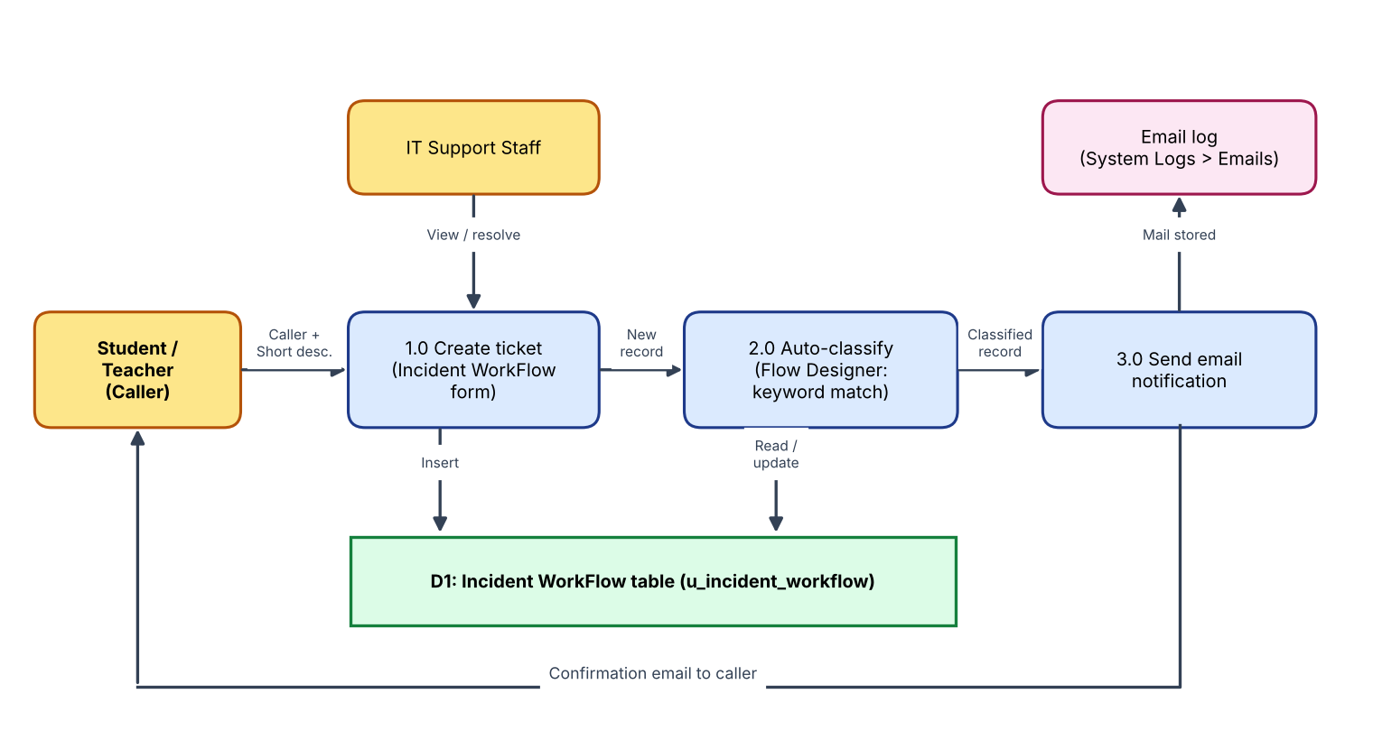

User Stories
Use the below template to list all the user stories for the product.
User Type | Functional Requirement (Epic) | User Story Number | User Story / Task | Acceptance criteria | Priority | Release
Student / Teacher (Caller) | Ticket Creation | USN-1 | As a caller, I can create an IT ticket by entering my name and a short description of the issue. | Ticket is saved with an auto-generated INC number | High | Sprint-3
 | Automatic Classification | USN-2 | As a caller, I want my ticket categorised automatically so I do not have to pick a category. | Category and Subcategory are filled after saving | High | Sprint-2
 | Email Notification | USN-3 | As a caller, I receive an email confirming my request was submitted. | Email appears in System Logs > Emails for the caller | High | Sprint-2
IT Support Agent | Ticket Handling | USN-4 | As an IT agent, I see tickets already classified so I can act without manual triage. | Category and Subcategory are present on every new ticket | High | Sprint-2
 | Ticket Handling | USN-5 | As an IT agent, I can set State, Assigned group and Assigned to on a ticket. | Reference fields resolve to sys_user_group and sys_user | Medium | Sprint-1
Administrator | Data Model | USN-6 | As an administrator, I can create a custom table with auto-numbering to store tickets. | Table Incident WorkFlow exists with INC auto-number | High | Sprint-1
 | Data Model | USN-7 | As an administrator, I can define choice fields and dependent Category > Subcategory logic. | Subcategory options change with the selected Category | High | Sprint-1
 | Flow Automation | USN-8 | As an administrator, I can maintain classification rules in Flow Designer without code. | New keyword is added by an Else-If branch | Medium | Sprint-2
 | Deployment | USN-9 | As an administrator, I can capture all changes in an update set and export it as XML. | Update set is Complete and XML downloads | Medium | Sprint-3
 | Security | USN-10 | As an administrator, I can restrict ticket data to authorised users. | Unauthorised users cannot read or modify the table | Medium | Sprint-3

